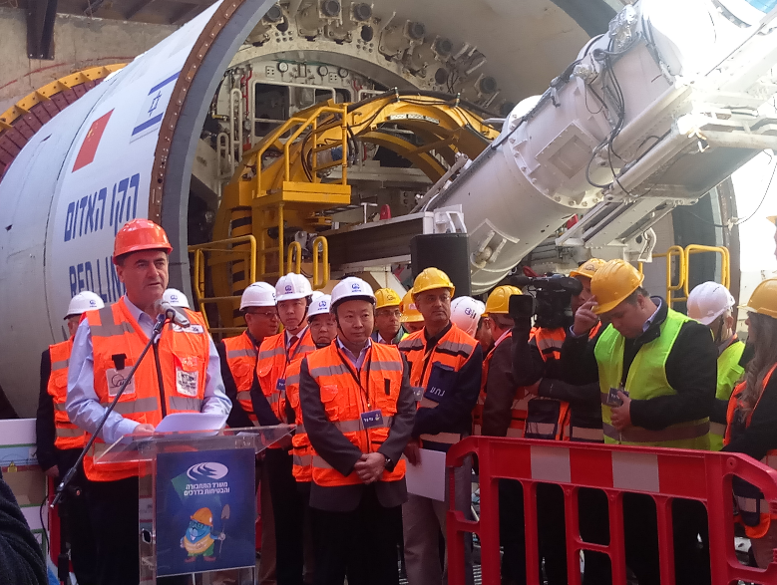
On the morning of 20 February, a remarkable ceremony of TBM launching has been held in Tel Aviv district in Israel. More than 300 guests, including Israel Minister of transport, Chinese ambassador witnessed CREG’s success and shared the glorious moment.
Launching ceremony
CREG ‘‘Golda’’ EPB TBM launched in Israel

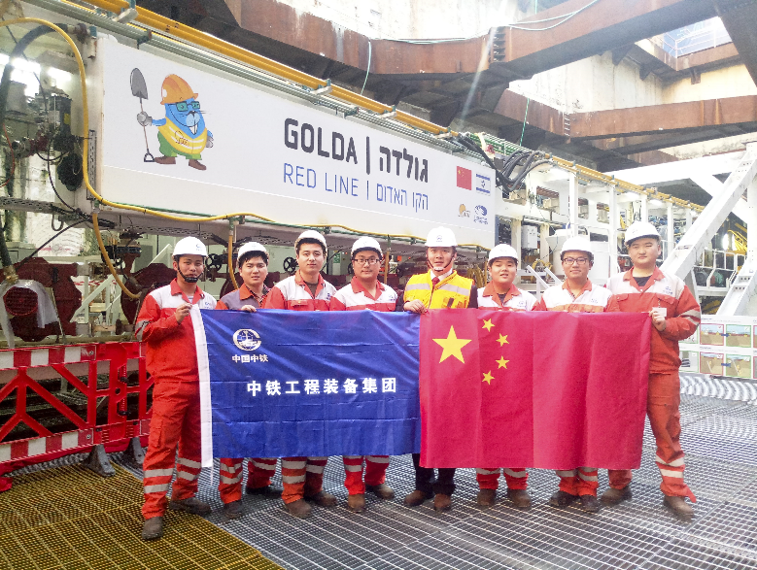
Tel Aviv is the second biggest city in Israel, with a large population. To reduce traffic congestion, Israel government decided to construct seven light rail lines. Red line is one of the seven lines with a total length 23km and consisting of TBM section, traditional excavating section and 23 stations. CREG signed up a contract to supply 6 EPB TBMs for red line west machining section.
CREG service team
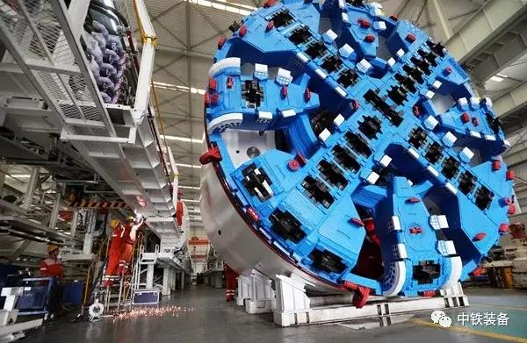
CREG ‘‘Golda’’ TBM is 105m long with diameter 7.53m. This machine has been manufactured according to the local construction standards to strictly satisfy high level QSHE requirements. TBM was launched at Galei Gil shaft and will be received at Ben Gurion station, thereinto passing through Aylon River, highway and five important landmarks. Tunnel was mainly built in soft ground condition. The revealed geology are clay and sand. The main concern is boring beneath riverbed. The overburden is less than 4m, in addition two concrete piles foundation with one meter diameter penetrated through the riverbed will be an obstacle while tunneling. So how to limit the settlement and crush concrete piles will be the crucial challenges.
TBM in factory
The TBM main characters are as follows:
- Boring diameter: 7530 mm
- Total length: 105 m
- Total weight: 780 ton
- Total drive power: 1600 kw
- Total installed power: 2673 kw
- Max. advance speed: 80 mm/min
- Thrust force: 55750 kN
- Breakout torque: 14000 kN∙m
- Rotation speed: 0 to 3 rpm
- Max. working pressure: 5 bar
- Min. horizontal radius: 200 m
- Max. climbing slope: 5%

